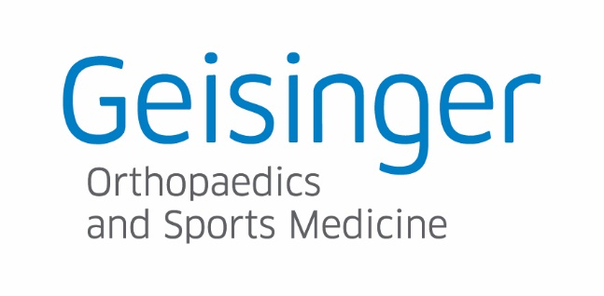
Sports Physicals for Spring Sport Athletes
Date: February 29, 2024
Location: Geisinger Orthopaedics & Sports Medicine
1175 East Mountain Blvd
Wilkes-Barre, PA 18702
Times:
4:00pm – Wyoming Valley West (all spring athletes)
4:30pm - Hanover Area School District (all spring athletes)
4:45pm – Wyoming Area School District (all spring athletes)
5:00pm – Northwest School District (all spring sports)
5:15pm- Greater Nanticoke Area School District (all spring sports)

Guidelines
- This is for Spring athletes for the above School Districts
- All athletes MUST have a completed and signed PIAA Physical packet in order to be eligible for a physical. Please bring Medical History and physical forms with you. (Sections 6 and 7 of PIAA sports physical packet)
- All athletes need to adhere to the scheduled times listed above. Please do not arrive early for you physical.

